Measurement Protocol PAX

# General Information:

|  |  |  |
| --- | --- | --- |
| Test date: 09/04/19 | Date prev. test: NA | Test number: 1 |
| Tested by: Alex Pollak | PAX number: PB-040 | Installed at ant.: NA |
| Comments: Bumpy passbands | | |
|  | | |
|  | | |
|  | | |
| Known problems: When installed on 3c the temperature stabilisation didn’t work and was | | |
| running with full power. Needs to be checked when installed next time. | | |
|  | | |
|  | | |

# Setup:

|  |  |  |  |
| --- | --- | --- | --- |
| Power supply: | OK 🗹 NOK 🗆 | Communication: | OK 🗹 NOK 🗆 |
| Supply current +6V: 1.108A | | ssh obs@antcntl | |
| Supply current -6V: 0.113A | | ssh ataant@ant0 | pw: q@n@t |
| Supply current +5V: 0.076A | | telnet pax | “help” |
|  | | CTRL + ] | “close” |

# RF Test with VNA:

### VNA Setup:

|  |  |  |
| --- | --- | --- |
| Load configuration: Passband_PAX.csa | | |
| Freq Start: 1.0 GHz | Freq Stop: 13.0 GHz | Power Level: -20 dBm |
| Averaging: enabled | Averaging count: 15 | N. Points: 801 |
| VNA : Agilent N5230C 10MHz - 20GHz | | |

|  |  |  |  |  |
| --- | --- | --- | --- | --- |
| VNA to PAX connection: | 1m ABC-CA18 Cable + 20dB Attenuator | | | |
| Input Power Level to PAX: (Measured) | @1GHz:  -40.2dBm | @4GHz:  -40.7dBm | @8GHz: -41.2dBm | @12GHz: -41.4dBm |

|  |  |
| --- | --- |
| PAX to VNA connection: | 2m Fibre Cable + Fibre Diode + AOX Amplifier + 1m ABC-CA18 Cable |

### Measured Passband with Attenuator set to 7dB each (Complete Link):

|  |
| --- |
| X |

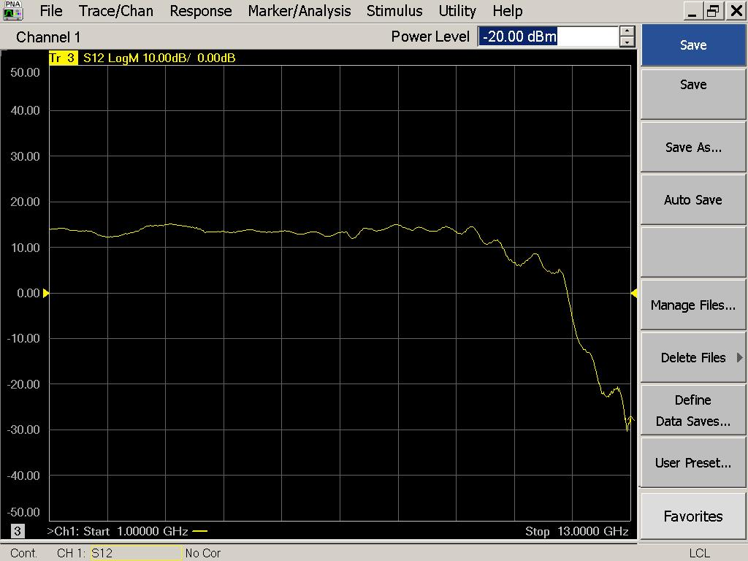

|  |  |  |  |
| --- | --- | --- | --- |
| Flatness: | OK 🗹 NOK 🗆 | Unwanted Features: | Yes 🗹 No 🗆 |

|  |
| --- |
| Y |

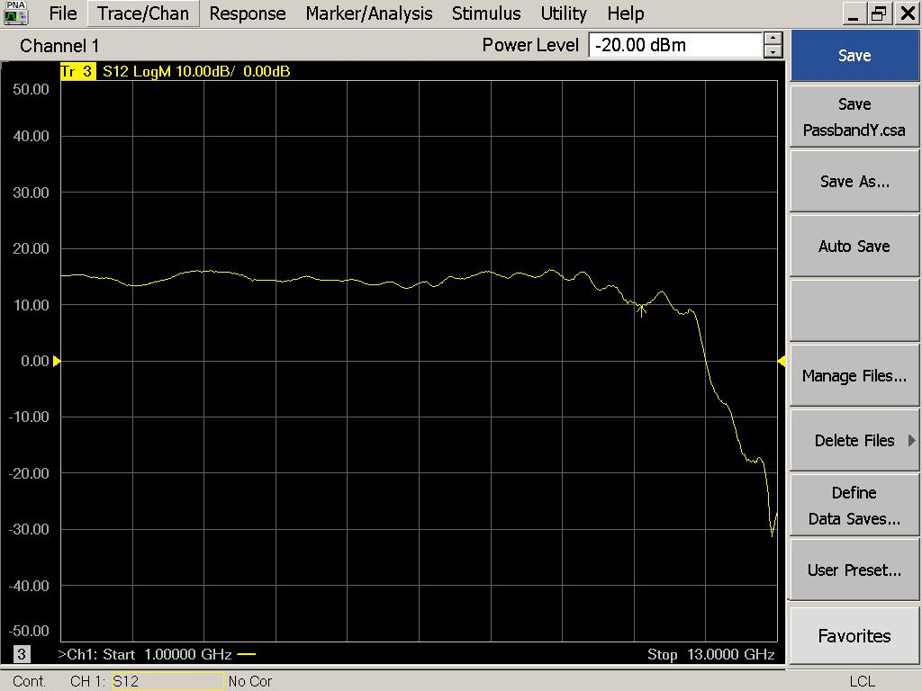

|  |  |  |  |
| --- | --- | --- | --- |
| Flatness: | OK 🗹 NOK 🗆 | Unwanted Features: | Yes 🗹 No 🗆 |

### Power Sweep (Complete Link):

|  |  |  |
| --- | --- | --- |
| Load configuration: Power_Sweep_PAX.csa | | |
| Power Start: -40dBm | Power Stop: -20dBm | Frequency : 4.0GHz |
| PAM Attenuator: 0dB |  | N. Points: 801 |

|  |
| --- |
| X |

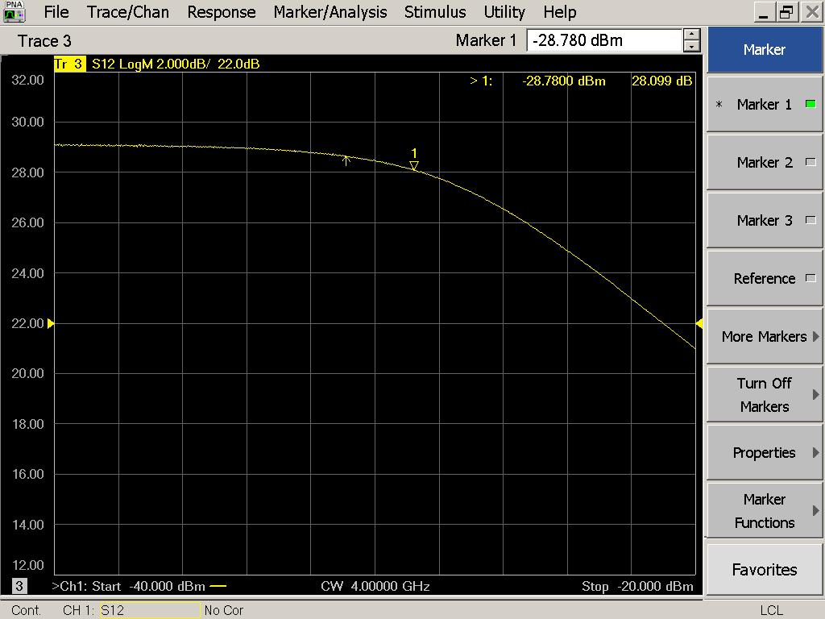

|  |  |  |  |
| --- | --- | --- | --- |
| Compression point: | OK 🗹 NOK 🗆 | Unwanted Features: | Yes 🗆 No 🗹 |

|  |
| --- |
| Y |

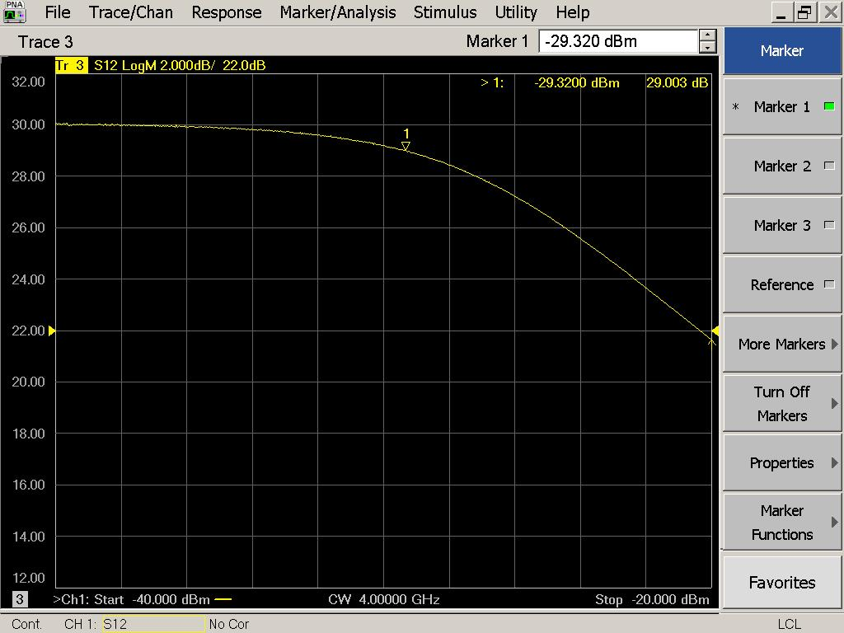

|  |  |  |  |
| --- | --- | --- | --- |
| Compression point: | OK 🗹 NOK 🗆 | Unwanted Features: | Yes 🗆 No 🗹 |

### Detector Calibration and Attenuator Sweep Pol X:

|  |  |  |
| --- | --- | --- |
| Load configuration: Detector_Calibration_PAX.csa | | |
| Freq : 4.0 GHz | Power Level: -20dBm | Sweep Time: -20sec |
| Sweep Mode: CW | Power Level at PAX Input (Measured): -40.6dBm | |

|  |  |  |  |  |
| --- | --- | --- | --- | --- |
| X | | | | |
| CW Input Power [dBm]: | Attenuator Value A [dB]: | Attenuator Value: B [dB]: | Detector Value: | Power Meter  Value [dBm]: |
| -40.6 | 0 | 0 | - | 13.20 |
| -40.6 | 0 | 3 | - | 13.24 |
| -40.6 | 0 | 6 | - | 12.63 |
| -40.6 | 0 | 9 | - | 10.32 |
| -40.6 | 0 | 12 | 0.8565 | 7.35 |
| -40.6 | 0 | 15 | 0.8566 | 4.62 |
| -40.6 | 0 | 18 | 0.5631 | 1.26 |
| -40.6 | 0 | 21 | 0.3158 | -1.90 |
| -40.6 | 3 | 21 | 0.1603 | -5.33 |
| -40.6 | 6 | 21 | 0.0852 | -8.36 |
| -40.6 | 9 | 21 | 0.0445 | -11.37 |
| -40.6 | 12 | 21 | 0.0234 | -14.34 |
| -40.6 | 15 | 21 | 0.0122 | -17.36 |
| -40.6 | 18 | 21 | 0.0063 | -20.58 |
| -40.6 | 21 | 21 | 0.0036 | -23.67 |
| -40.6 | 24 | 21 | 0.0024 | -26.51 |
| -40.6 | 27 | 21 | 0.0016 | -29.61 |
| -40.6 | 30 | 21 | 0.0014 | -32.74 |
| -40.6 | 30 | 24 | 0.0012 | -35.26 |
| -40.6 | 30 | 27 | 0.0011 | -37.66 |
| -40.6 | 30 | 30 | 0.0010 | -39.95 |

|  |  |  |
| --- | --- | --- |
| Use Noise Source: Atlantic AS6333 | | |
| Freq : 1.0 - 12.0GHz | Power Level: -41.8dBm |  |
| DC Supply: 28V |  | |

|  |  |  |  |  |
| --- | --- | --- | --- | --- |
| X | | | | |
| CW Input Power [dBm]: | Attenuator Value A [dB]: | Attenuator Value: B [dB]: | Detector Value: | Power Meter  Value [dBm]: |
| -41.8 | 0 | 0 | - | 11.90 |
| -41.8 | 0 | 3 | - | 11.03 |
| -41.8 | 0 | 6 | - | 9.61 |
| -41.8 | 0 | 9 | 0.8562 | 7.68 |
| -41.8 | 0 | 12 | 0.8564 | 5.05 |
| -41.8 | 0 | 15 | 0.7975 | 2.63 |
| -41.8 | 0 | 18 | 0.4370 | -0.60 |
| -41.8 | 0 | 21 | 0.2385 | -3.62 |
| -41.8 | 3 | 21 | 0.1256 | -6.61 |
| -41.8 | 6 | 21 | 0.0631 | -9.72 |
| -41.8 | 9 | 21 | 0.0331 | -12.61 |
| -41.8 | 12 | 21 | 0.0169 | -15.63 |
| -41.8 | 15 | 21 | 0.0096 | -18.32 |
| -41.8 | 18 | 21 | 0.0051 | -21.62 |
| -41.8 | 21 | 21 | 0.0032 | -24.69 |
| -41.8 | 24 | 21 | 0.0022 | -27.67 |
| -41.8 | 27 | 21 | 0.0018 | -30.44 |
| -41.8 | 30 | 21 | 0.0014 | -33.67 |
| -41.8 | 30 | 24 | 0.0014 | -36.16 |
| -41.8 | 30 | 27 | 0.0013 | -38.27 |
| -41.8 | 30 | 30 | 0.0012 | -40.42 |

### Detector Calibration and Attenuator Sweep Pol Y:

|  |  |  |
| --- | --- | --- |
| Load configuration: Detector_Calibration_PAX.csa | | |
| Freq : 4.0 GHz | Power Level: -20dBm | Sweep Time: -20sec |
| Sweep Mode: CW | Power Level at PAX Input (Measured): -40.6dBm | |

|  |  |  |  |  |
| --- | --- | --- | --- | --- |
| Y | | | | |
| CW Input Power [dBm]: | Attenuator Value A [dB]: | Attenuator Value: B [dB]: | Detector Value: | Power Meter  Value [dBm]: |
| -40.6 | 0 | 0 | - | 13.14 |
| -40.6 | 0 | 3 | - | 13.15 |
| -40.6 | 0 | 6 | - | 12.37 |
| -40.6 | 0 | 9 | - | 9.93 |
| -40.6 | 0 | 12 | 0.8524 | 6.94 |
| -40.6 | 0 | 15 | 0.8526 | 4.13 |
| -40.6 | 0 | 18 | 0.5259 | 0.81 |
| -40.6 | 0 | 21 | 0.2955 | -2.24 |
| -40.6 | 3 | 21 | 0.1507 | -5.56 |
| -40.6 | 6 | 21 | 0.0791 | -8.58 |
| -40.6 | 9 | 21 | 0.0410 | -11.60 |
| -40.6 | 12 | 21 | 0.0212 | -14.60 |
| -40.6 | 15 | 21 | 0.0112 | -17.57 |
| -40.6 | 18 | 21 | 0.0058 | -20.83 |
| -40.6 | 21 | 21 | 0.0033 | -23.95 |
| -40.6 | 24 | 21 | 0.0022 | -26.84 |
| -40.6 | 27 | 21 | 0.0015 | -29.90 |
| -40.6 | 30 | 21 | 0.0012 | -33.10 |
| -40.6 | 30 | 24 | 0.0010 | -35.74 |
| -40.6 | 30 | 27 | 0.0010 | -38.15 |
| -40.6 | 30 | 30 | 0.0009 | -40.36 |

|  |  |  |
| --- | --- | --- |
| Use Noise Source: Atlantic AS6333 | | |
| Freq : 1.0 - 12.0GHz | Power Level: -41.8dBm |  |
| DC Supply: 28V |  | |

|  |  |  |  |  |
| --- | --- | --- | --- | --- |
| Y | | | | |
| CW Input Power [dBm]: | Attenuator Value A [dB]: | Attenuator Value: B [dB]: | Detector Value: | Power Meter  Value [dBm]: |
| -41.8 | 0 | 0 | - | 11.81 |
| -41.8 | 0 | 3 | - | 10.93 |
| -41.8 | 0 | 6 | - | 9.52 |
| -41.8 | 0 | 9 | - | 7.58 |
| -41.8 | 0 | 12 | 0.8524 | 4.96 |
| -41.8 | 0 | 15 | 0.7679 | 2.50 |
| -41.8 | 0 | 18 | 0.4153 | -0.71 |
| -41.8 | 0 | 21 | 0.2274 | -3.63 |
| -41.8 | 3 | 21 | 0.1194 | -6.56 |
| -41.8 | 6 | 21 | 0.0587 | -9.69 |
| -41.8 | 9 | 21 | 0.0305 | -12.60 |
| -41.8 | 12 | 21 | 0.0153 | -15.64 |
| -41.8 | 15 | 21 | 0.0088 | -18.29 |
| -41.8 | 18 | 21 | 0.0047 | -21.60 |
| -41.8 | 21 | 21 | 0.0029 | -24.69 |
| -41.8 | 24 | 21 | 0.0020 | -27.68 |
| -41.8 | 27 | 21 | 0.0016 | -30.38 |
| -41.8 | 30 | 21 | 0.0014 | -33.62 |
| -41.8 | 30 | 24 | 0.0012 | -36.27 |
| -41.8 | 30 | 27 | 0.0012 | -38.38 |
| -41.8 | 30 | 30 | 0.0012 | -40.52 |

# LNA Bias Supply:

Note that the bias supply is tested without an LNA connected to the PAX box!

|  |  |
| --- | --- |
| Enable Supply: “lnabiaslatch” | Disable Supply: “lnabiasoff” |

|  |  |  |  |
| --- | --- | --- | --- |
| X | | Y | |
| Vg: | 0.19 | Vg: | 0.02 |
| Vd: | 1.23 | Vd: | 1.23 |
| Vm: | -0.52 | Vm: | -0.52 |
| Id: | 0.1 | Id: | 0.1 |
| Bias Supply: OK 🗹 NOK 🗆 | | Bias Supply: OK **🗹** NOK 🗆 | |

# Inspection:

### Visual:

|  |  |  |
| --- | --- | --- |
| Fibre Connectors Clean | Comments: | OK 🗹 NOK 🗆 |
| Fibre Connector Mechanical | Comments: | OK **🗹** NOK **🗆** |
| RF Cable | Comments: | OK **🗹** NOK **🗆** |
| RF Connectors Clean | Comments: | OK **🗹** NOK **🗆** |

### Functions:

|  |  |  |
| --- | --- | --- |
| Read Temperature Value | Comments: 34.8 | OK 🗹 NOK 🗆 |
| LNA Settings | Comments: | OK 🗆 NOK **🗆** |
| Temperature Stabilisation | Comments: | OK 🗆 NOK **🗆** |
| Software Version: | Date: 2007/11/15 18:00:00 Revision: 1.10 pax controller | OK **🗹** NOK **🗆** |